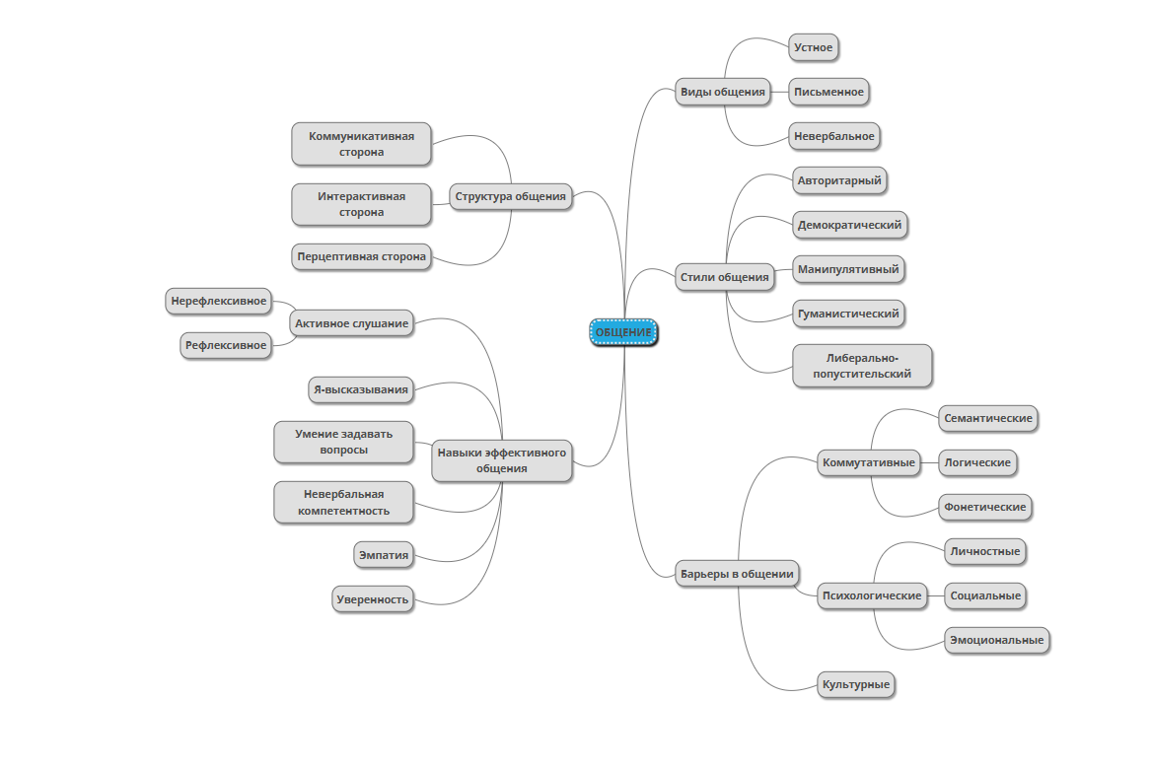

https://app.mindmup.com/map/_free/2025/09/4e25a9d09c6011f0a37b9921039b93a9